# Lora Web Portal

The Lora web portals allow user access to the role endpoints remotely.there are 2 main user type,admin and user.

ERD:

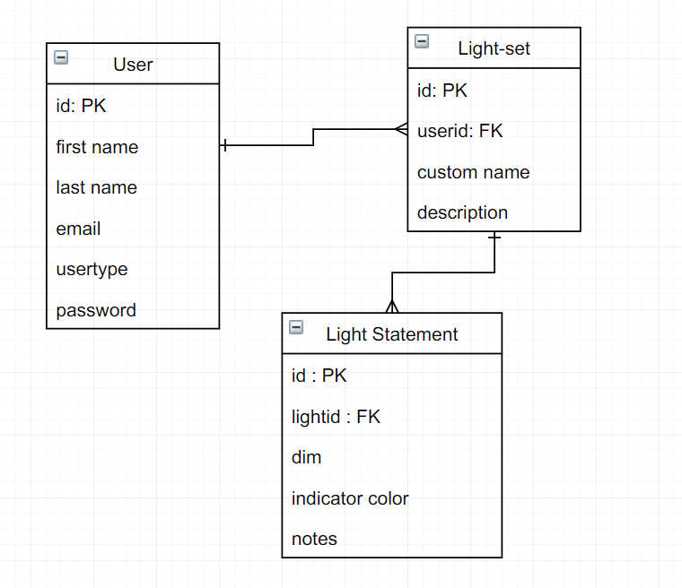

Note:

* 2 user type:
  + Admin
  + Client

## UX:

Login & Register Page

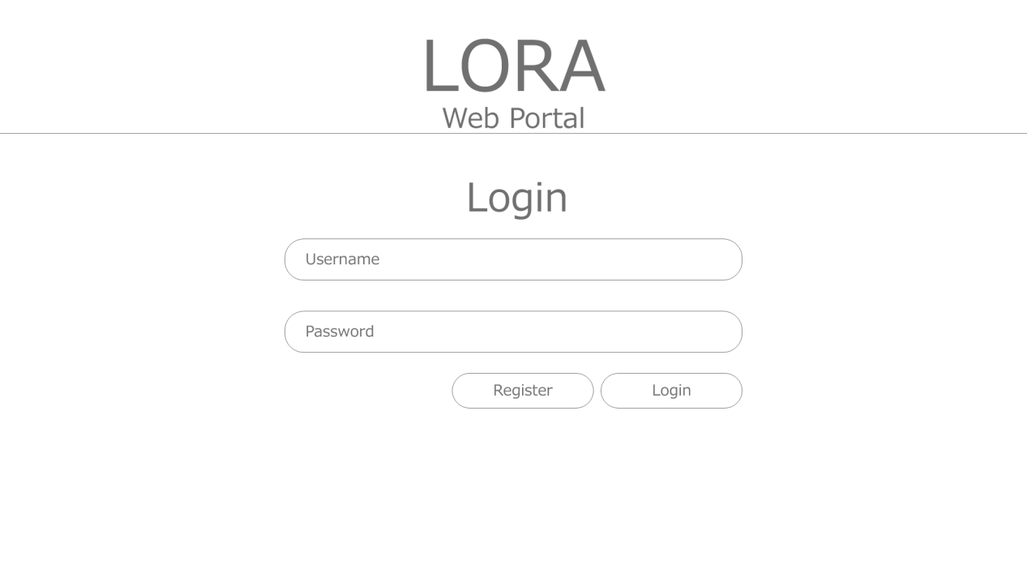

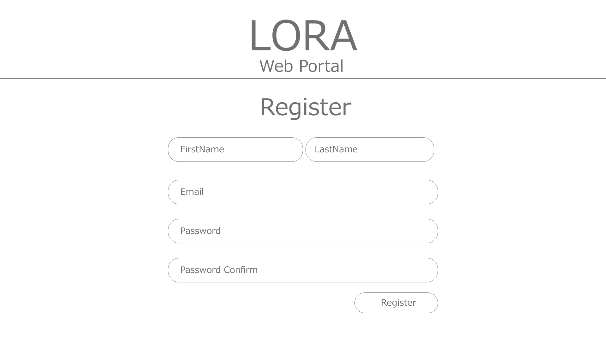

Note:

User can self register their account and the admin can align the Lora endpoints to user.

## Dashboard

## Dashboard

## Dashboard - Lora management

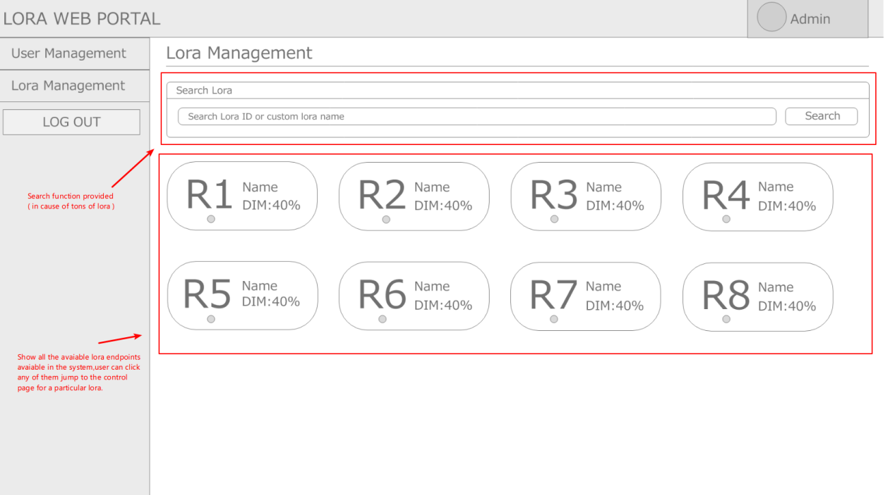

Note: Admin can view all the Lora endpoints

## 

## Dashboard - Lora control (for a particular Lora)

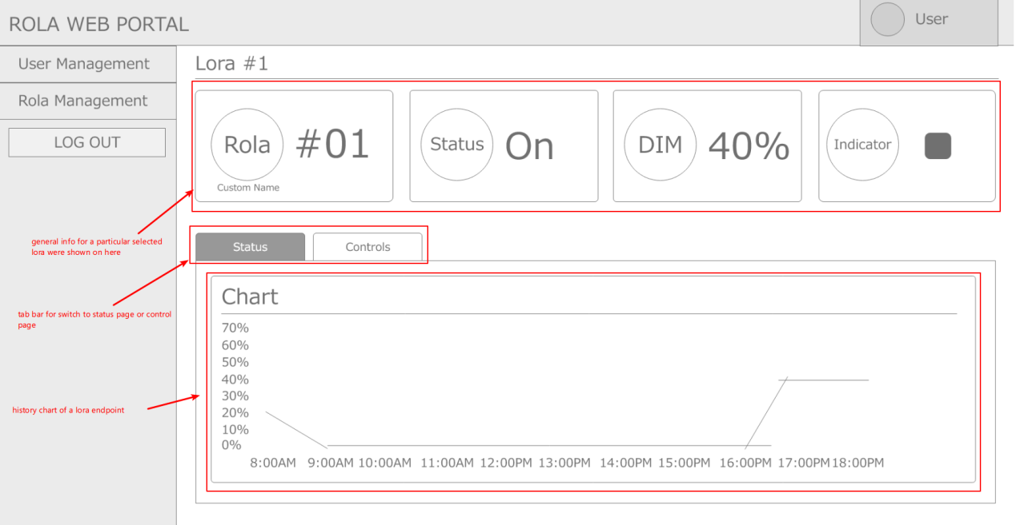

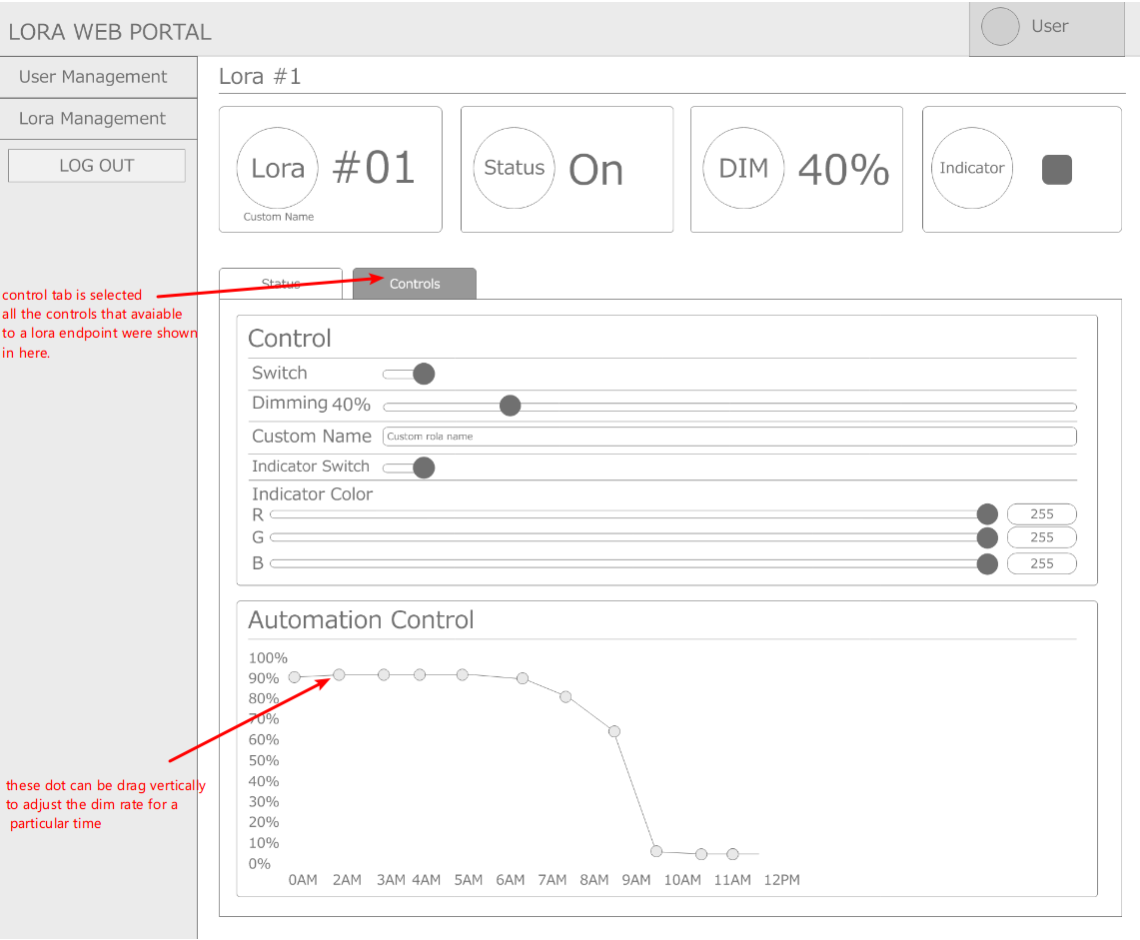

Note:

* This page is open when the one Lora endpoint has selected from previous page.
* All controls relate to the particular Lora endpoints can be found on this page.

## Dashboard - user management (Admin only)

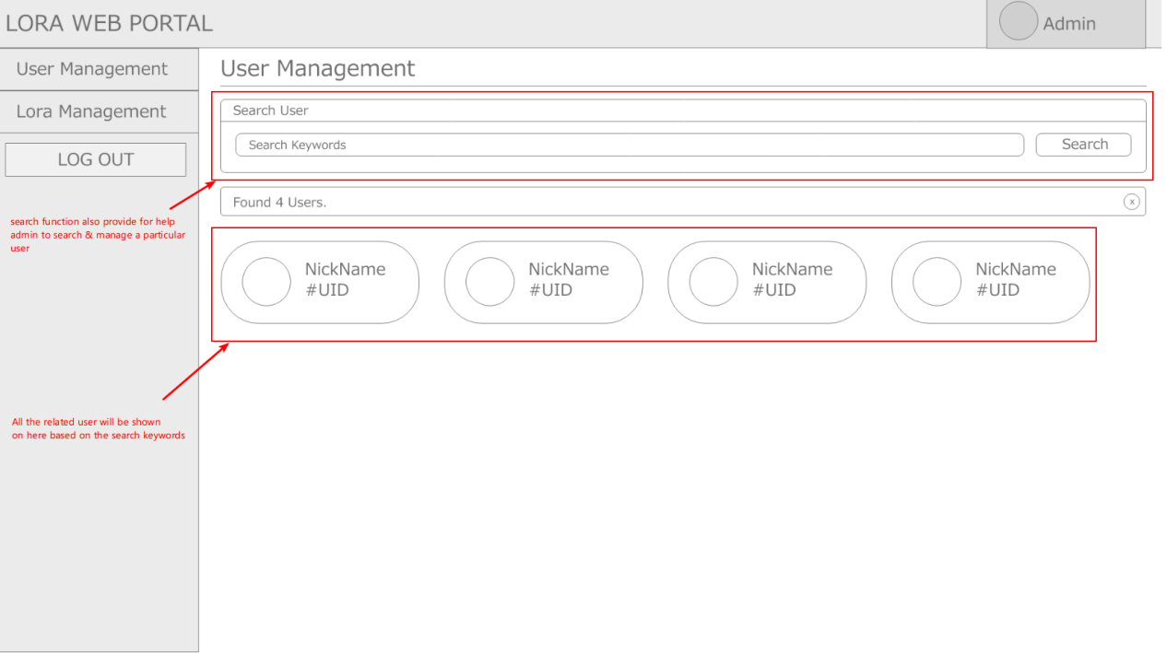

## Dashboard - particular user management (Admin only)

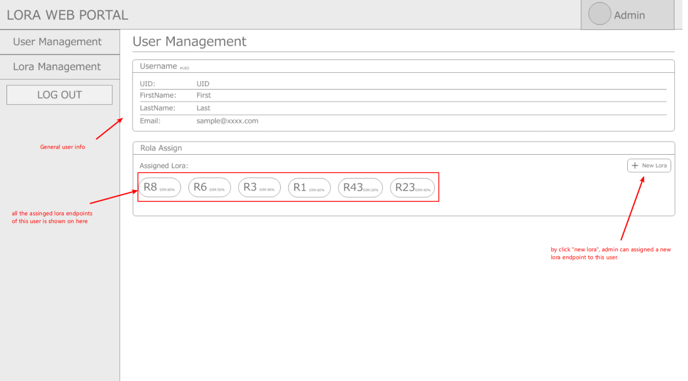

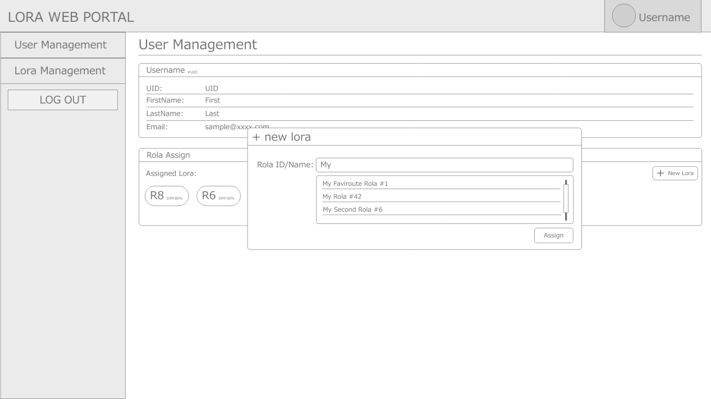

Note: the “new rola” modal will pop up when button “+ New Lora” is clicked

## Dashboard - User

Note:

* for the “particular Lora control page”, is basically same as admin, it wont shown again in here.

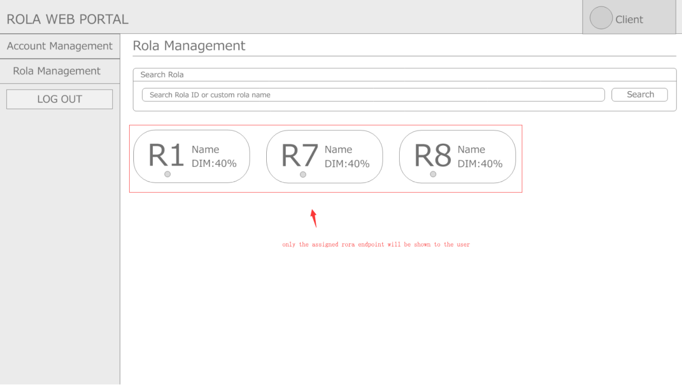

## Dashboard - User account management

